Exercise 1: Implementing the Singleton Pattern

using System;
public sealed class Logger
{
private static Logger instance;
// Private constructor
private Logger()
{
}
// Returns the single instance of Logger
public static Logger GetInstance()
{
if (instance == null)
{
instance = new Logger();
}
return instance;
}
// Method to display log message
public void Log(string message)
{
Console.WriteLine("LOG: " + message);
}
}

class Program
{
static void Main(string[] args)
{
Logger logger1 = Logger.GetInstance();
Logger logger2 = Logger.GetInstance();
logger1.Log("Application Started");
if (Object.ReferenceEquals(logger1, logger2))
{
Console.WriteLine("Both objects are the same (Singleton).");
}
else
{
Console.WriteLine("Objects are different.");
}
}
}

OUTPUT:
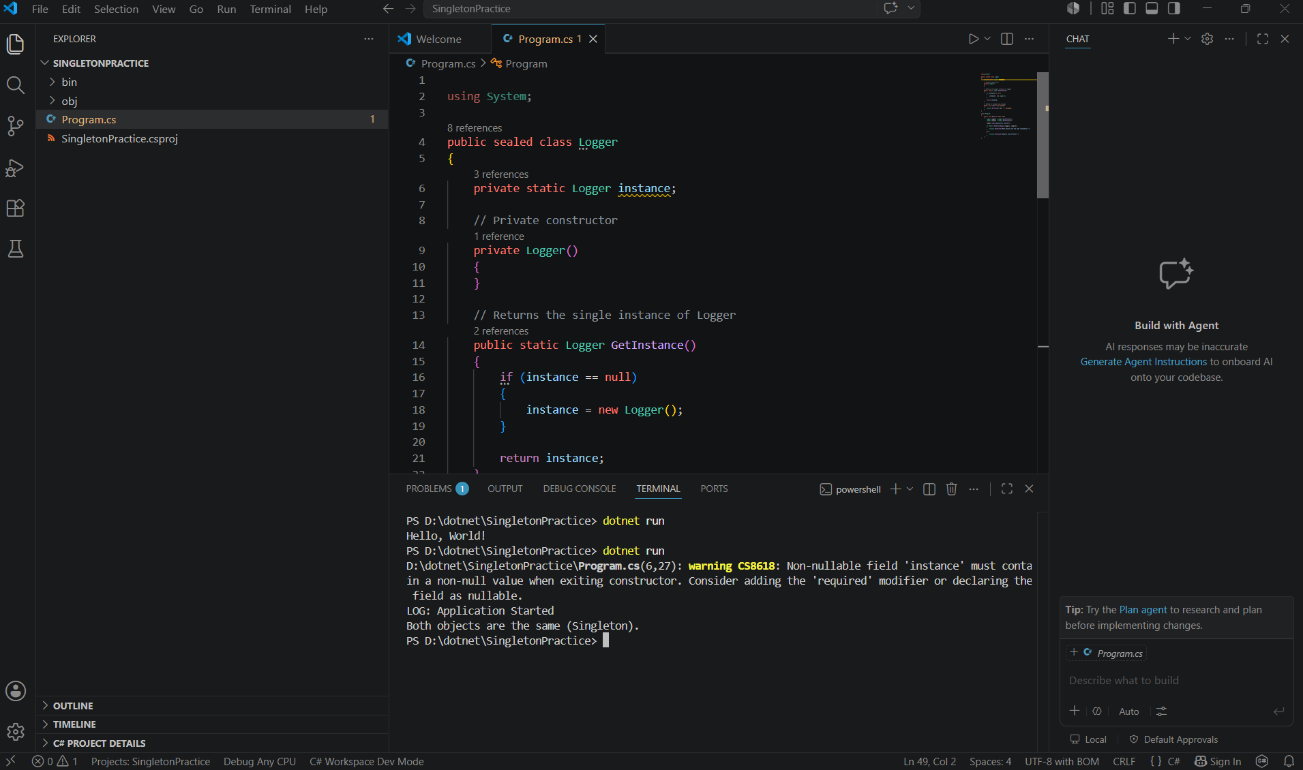

Exercise 2: Implementing the Factory Method Pattern

using System;
interface IShape
{
void Draw();
}

class Circle : IShape
{
public void Draw()
{
Console.WriteLine("Drawing Circle");
}
}
class Rectangle : IShape
{
public void Draw()
{
Console.WriteLine("Drawing Rectangle");
}
}
class ShapeFactory
{
public static IShape GetShape(string shape)
{
if (shape == "Circle")
return new Circle();
return new Rectangle();
}
}
class Program
{
static void Main(string[] args)
{
IShape shape1 = ShapeFactory.GetShape("Circle");
shape1.Draw();

IShape shape2 = ShapeFactory.GetShape("Rectangle");
shape2.Draw();
}
}
OUTPUT:
